Sprint 2 Deliverables

Introduction
This section explains the work I completed for Sprint 2. First, it shows how a program can find the public IP address that the internet sees when a device connects online. Second, it explains what information a VPN leak detection system needs to look at and what kind of results it should give back. Together, these steps help determine whether a VPN is properly hiding a user’s internet identity.

Public IPv4 Address Retrieval
The public IPv4 address was retrieved programmatically using a Python script that issued an HTTP GET request to a public IP reflection service. This method is non-invasive, operates entirely in user space, and requires no privileged access, consistent with the approach taken in Sprint 1. The script was executed locally, and the retrieved IPv4 address was successfully displayed in the terminal, with screenshots included for documentation.

Retrieving the public IPv4 address provides a baseline for evaluating whether a VPN is properly masking the user’s network identity, making it a core component of IPv4 leak detection within the project.

During testing, it was observed that depending on VPN configuration (I think), the public IPv4 address may remain unchanged even when a VPN is enabled, reinforcing the need for explicit leak detection.

Public IP reflection service used: https://api.ipify.org/
Backup: checkip.amazonaws.com

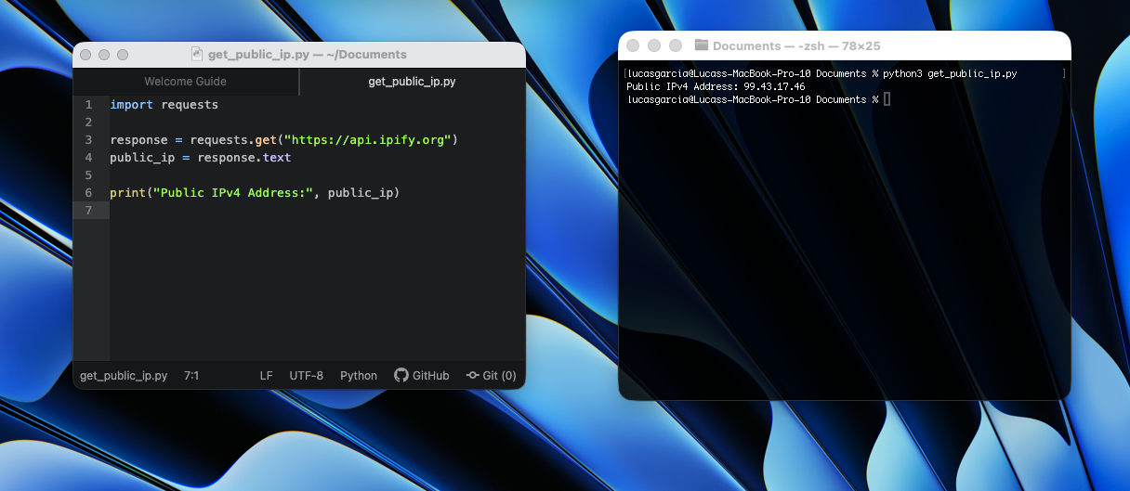
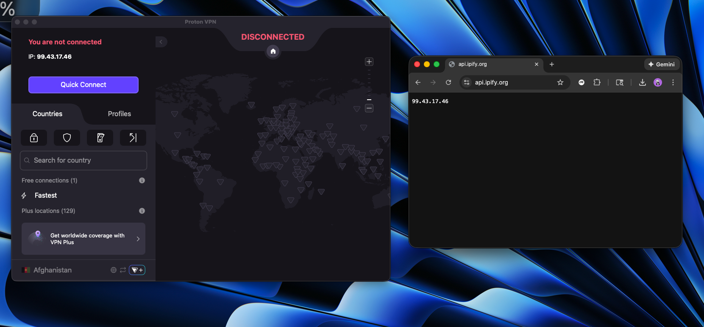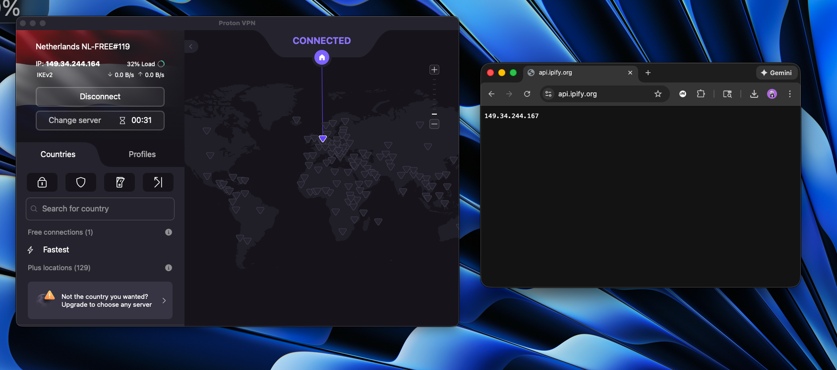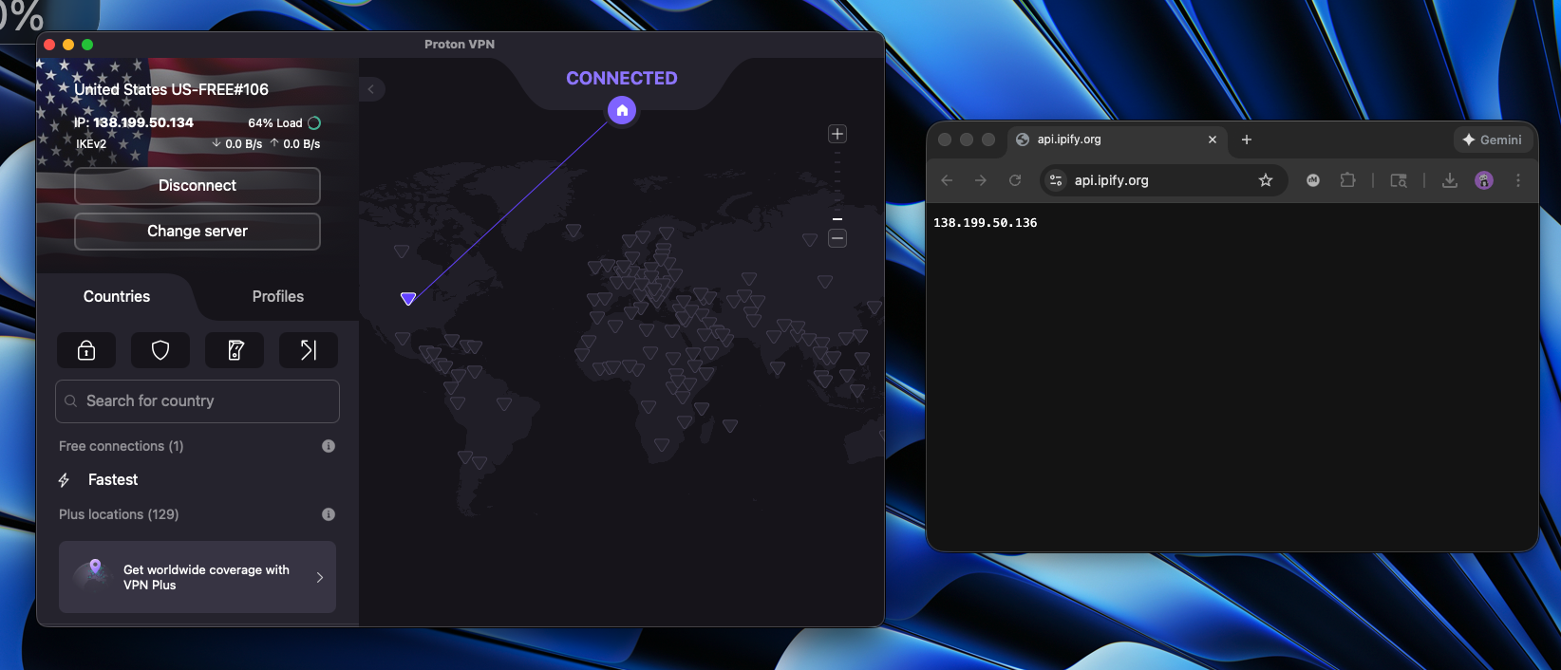

Expected Inputs and Outputs for Leak Detection
This deliverable defines the specific inputs the leak detection system is expected to observe and the outputs it should produce. Rather than implementing detection logic, the goal is to establish a clear and consistent structure for how leak detection results will be evaluated and reported in future development.
Inputs to the system include the following externally observable network information: (1) the user’s public IPv4 address, (2) the DNS resolver address in use, (3) any WebRTC-discovered IP addresses, and (4) the current VPN state (enabled or disabled). These inputs represent the data points that may indicate whether a VPN is properly masking the user’s network identity.
Outputs of the system define how detection results are communicated. These outputs include (1) a leak determination (leak or no leak), (2) the specific type of leak identified (e.g., IPv4, DNS, WebRTC), and (3) the observed values that contributed to the determination. Defining these inputs and outputs establishes a clear foundation for implementing consistent, interpretable, and non-invasive leak detection logic in future stages of the project.

